Cactus Store Order
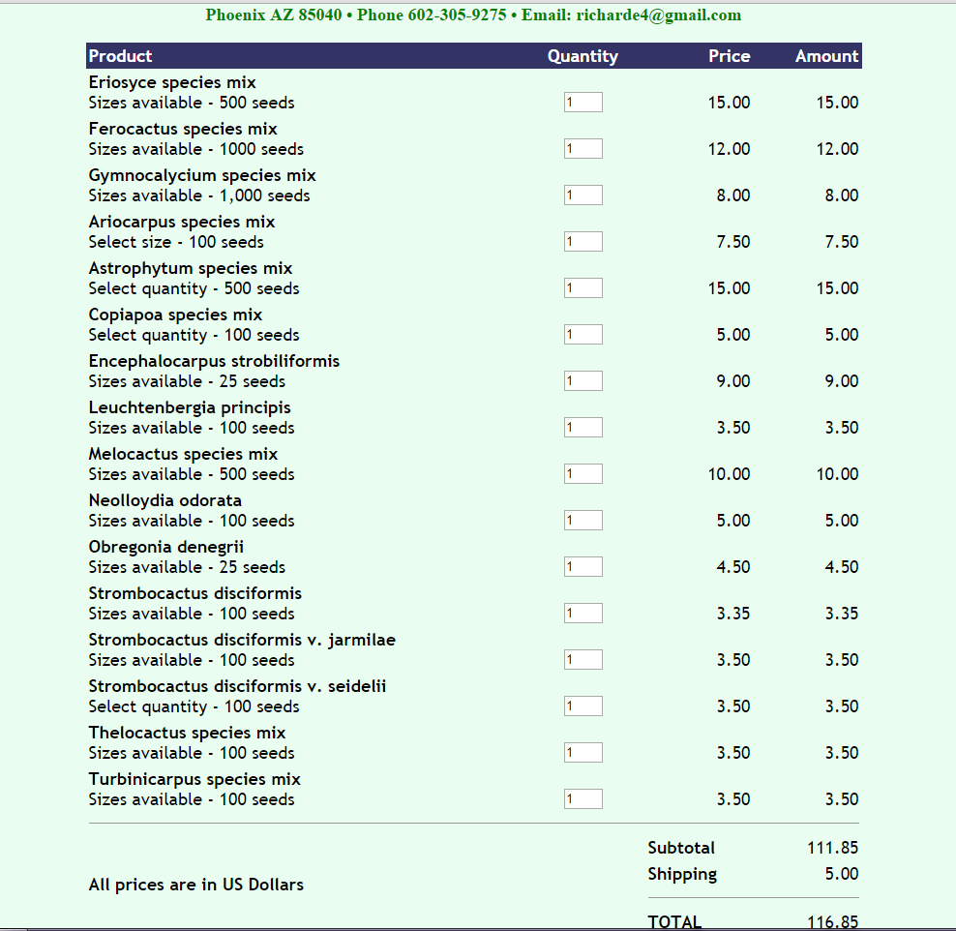
Lloyd and Katie = 58.40 each
Star Astrophytum
Lloyd and Katie
A. Digitostigma caput-medusae ČR Code: s52
Package [pc]: 10
Price: 4 EUR
A. asterias nudum Ooibo THAILAND Code: s56
Package [pc]: 100!!!
Price: 16 EUR
Star Astrophytum myriostigma set mix Japan 300 seeds Code: s58
Package [pc]: 300
Price: 49 EUR
Star Astrophytum asterias set mix Japan + Thailand 300 seeds Code: s59
Package [pc]: 300
Price: 45 EUR
Total: 114 Euro

